SIMATS ENGINEERING
ASSESSMENT TOOL 3

COURSE NAME: Artificial Intelligence COURSE CODE: CSA17
NAME:Gayathri.P
REGNO:192424324

COURSE OUTCOME COVERED
CO3: Analyze knowledge representation and reasoning using propositional logic, FOL, inference, resolution, chaining methods, knowledge representation to perform logical reasoning for drawing valid conclusions and decision making. (BL4)

Assessment Tool Weightage: 20%

Time Duration: 1 Hour
QUESTIONS: 5 Total Marks:30
Annexure A
Resolution Algorithm Implementation

Code of Conduct:
I _Gayathri.P(192424324)_ (Name / Reg No) certify that this submission is my original work and that I have adhered to the guidelines specified for this assessment.
I understand that any violation of academic integrity rules will result in disciplinary action.

Signature of the student:

Annexure A

Resolution Algorithm Implementation

Question 1 – Rain and Wet Ground

Knowledge Base
- If it rains, then the ground becomes wet.
- It is raining.
Goal
Prove that the ground is wet using the Resolution Algorithm.

Tasks
- Represent the statements in propositional logic.
- Convert all statements into CNF.
Negate the goal.
- Apply the Resolution Algorithm step by step.
- Show the Empty Clause (□) if the goal is proved.

Question 2 – Student Assignment Submission

Knowledge Base
- If a student submits the assignment, then the student receives internal marks
- Rahul submitted the assignment.

Goal
Prove that Rahul receives internal marks using the Resolution Algorithm.

Tasks

Write the propositional logic expressions.

Convert the premises into CNF.
Negate the goal.
- Apply the Resolution Algorithm.
- Conclude whether the goal is proved.

Question 3 – Library Membership

Knowledge Base

If a person is a library member, then the person can borrow books.

Priya is a library member.

Goal
- Prove that Priya can borrow books using the Resolution Algorithm.

Tasks

Represent the knowledge base using propositional logic.

Convert each statement into CNF.
Negate the goal.
- Perform resolution until no new clauses can be generated.
- State the final conclusion.

Question 4 – Placement Eligibility

Knowledge Base

If a student clears the aptitude test, then the student is eligible for placement.

Arun cleared the aptitude test.

Goal

Prove that Arun is eligible for placement using the Resolution Algorithm.

Tasks

Convert the statements into propositional logic.

Write the CNF clauses.

Negate the goal.

Apply the Resolution Algorithm step by step.

Draw the resolution tree and conclude.

Question 5 – Access Control System

Knowledge Base

If a user enters the correct password, then the user is authenticated.

If a user is authenticated, then the user is granted access.

The user entered the correct password.

Goal
Prove that the user is granted access using the Resolution Algorithm.

Tasks

Represent the knowledge base in propositional logic.

Convert all implications into CNF.

Negate the goal.

Apply the Resolution Algorithm to derive the Empty Clause (□).

Explain each resolution step and write the final conclusion.

RUBRICS FOR CALCULATION

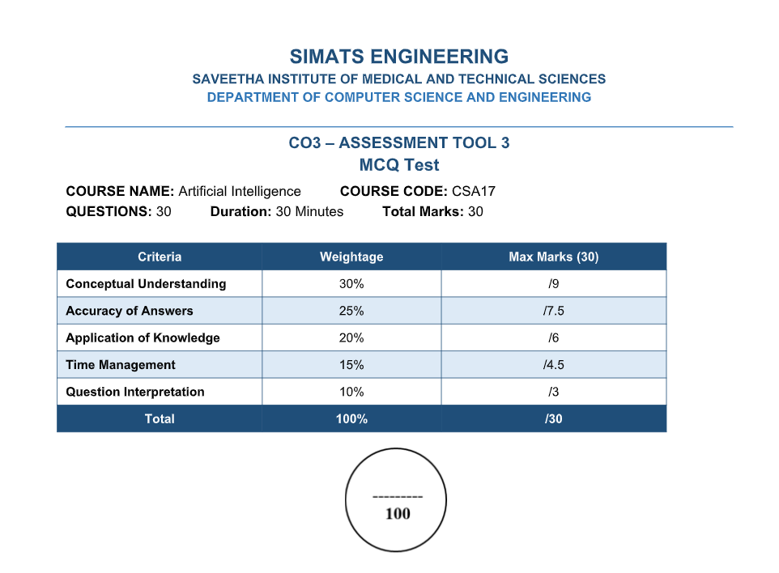

ANSWERS
Question 1 – Rain and Wet Ground
Knowledge Base
1. If it rains, then the ground becomes wet.
2. It is raining.
Goal
Prove that the ground is wet using the Resolution Algorithm.
Step 1: Represent in Propositional Logic
Let R = It is raining.
Let W = The ground is wet.
Statement 1: R → W
Statement 2: R
Goal: W
Step 2: Convert into CNF
R → W ≡ ¬R ∨ W
CNF clauses: C1: ¬R ∨ W; C2: R
Step 3: Negate the Goal
Goal: W
Negated goal: ¬W
Therefore: C1: ¬R ∨ W; C2: R; C3: ¬W
Step 4: Apply Resolution
Resolve C1 (¬R ∨ W) and C2 (R): complementary literals are ¬R and R. Therefore C4: W.
Resolve C4 (W) and C3 (¬W): complementary literals are W and ¬W. Therefore: □ (Empty Clause).

Resolution Tree
¬R ∨ W R
\ /
W
|
¬W
|
□
Final Conclusion
The empty clause □ is derived. Therefore, the negation of the goal leads to a contradiction. Hence, the ground is wet is proved using the Resolution Algorithm.

Question 2 – Student Assignment Submission
Knowledge Base
1. If a student submits the assignment, then the student receives internal marks.
2. Rahul submitted the assignment.
Goal
Prove that Rahul receives internal marks using the Resolution Algorithm.
Step 1: Propositional Logic
Let S = Rahul submitted the assignment.
Let M = Rahul receives internal marks.
Statement 1: S → M
Statement 2: S
Goal: M
Step 2: Convert into CNF
S → M ≡ ¬S ∨ M
CNF clauses: C1: ¬S ∨ M; C2: S
Step 3: Negate the Goal
Goal: M
Negated goal: ¬M
Complete clauses: C1: ¬S ∨ M; C2: S; C3: ¬M
Step 4: Apply Resolution
Resolve C1 (¬S ∨ M) and C2 (S): C4: M.
Resolve C4 (M) and C3 (¬M): □.
Resolution Tree
¬S ∨ M S
\ /
M
|
¬M
|
□
Final Conclusion
The resolution process produces the empty clause □. Therefore, the assumption that Rahul does not receive internal marks leads to a contradiction. Hence, Rahul receives internal marks.

Question 3 – Library Membership
Knowledge Base
1. If a person is a library member, then the person can borrow books.
2. Priya is a library member.
Goal
Prove that Priya can borrow books using the Resolution Algorithm.
Step 1: Propositional Logic
Let L = Priya is a library member.
Let B = Priya can borrow books.
Statement 1: L → B
Statement 2: L
Goal: B
Step 2: Convert into CNF
L → B ≡ ¬L ∨ B
CNF clauses: C1: ¬L ∨ B; C2: L
Step 3: Negate the Goal
Goal: B
Negated goal: ¬B
Complete clauses: C1: ¬L ∨ B; C2: L; C3: ¬B
Step 4: Apply Resolution
Resolve C1 (¬L ∨ B) and C2 (L): C4: B.
Resolve C4 (B) and C3 (¬B): □.

Resolution Tree
¬L ∨ B L
\ /
B
|
¬B
|
□
Final Conclusion
The resolution algorithm derives the empty clause □. Therefore, the negation of the goal is contradictory. Hence, Priya can borrow books.

Question 4 – Placement Eligibility
Knowledge Base
1. If a student clears the aptitude test, then the student is eligible for placement.
2. Arun cleared the aptitude test.
Goal
Prove that Arun is eligible for placement using the Resolution Algorithm.
Step 1: Propositional Logic
Let A = Arun cleared the aptitude test.
Let P = Arun is eligible for placement.
Statement 1: A → P
Statement 2: A
Goal: P
Step 2: Convert into CNF
A → P ≡ ¬A ∨ P
CNF clauses: C1: ¬A ∨ P; C2: A
Step 3: Negate the Goal
Goal: P
Negated goal: ¬P
Complete clauses: C1: ¬A ∨ P; C2: A; C3: ¬P
Step 4: Apply Resolution
Resolve C1 (¬A ∨ P) and C2 (A): C4: P.
Resolve C4 (P) and C3 (¬P): □.
Resolution Tree
¬A ∨ P A
\ /
P
|
¬P
|
□
Final Conclusion
The resolution process derives the empty clause □. Therefore, the negation of the goal results in a contradiction. Hence, Arun is eligible for placement.

Question 5 – Access Control System
Knowledge Base
1. If a user enters the correct password, then the user is authenticated.
2. If a user is authenticated, then the user is granted access.
3. The user entered the correct password.
Goal
Prove that the user is granted access using the Resolution Algorithm.
Step 1: Propositional Logic
Let P = The user entered the correct password.
Let A = The user is authenticated.
Let G = The user is granted access.
Statement 1: P → A
Statement 2: A → G
Statement 3: P
Goal: G
Step 2: Convert All Implications into CNF
P → A ≡ ¬P ∨ A
A → G ≡ ¬A ∨ G
Statement 3: P
CNF clauses: C1: ¬P ∨ A; C2: ¬A ∨ G; C3: P
Step 3: Negate the Goal
Goal: G
Negated goal: ¬G
Complete clause set: C1: ¬P ∨ A; C2: ¬A ∨ G; C3: P; C4: ¬G
Step 4: Apply Resolution
Resolution 1: Resolve C1 (¬P ∨ A) and C3 (P). The complementary literals are ¬P and P. Therefore C5: A.
Resolution 2: Resolve C2 (¬A ∨ G) and C5 (A). The complementary literals are ¬A and A. Therefore C6: G.
Resolution 3: Resolve C6 (G) with C4 (¬G). The complementary literals are G and ¬G. Therefore □.
Resolution Tree
¬P ∨ A P
\ /
A
|
¬A ∨ G
|
G
|
¬G
|
□
Final Conclusion
The resolution algorithm derives the empty clause □. This means that assuming the user is not granted access creates a contradiction. Therefore, the user entered the correct password → the user is authenticated → the user is granted access. Hence, the user is granted access is proved using the Resolution Algorithm.

